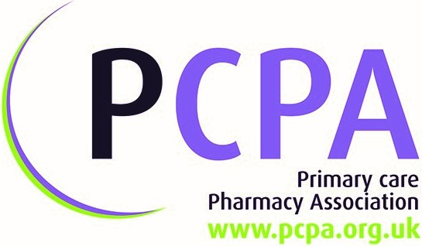
POSTER SUBMISSION GUIDE

The intention is that posters will focus on aspects of pharmacy, i.e. medicines optimisation, increased value to patients, improved care etc. The posters will be a good starting point for the exchange of knowledge. Your idea will inspire other people into further exploration of the subject matter.
What subjects are suitable for a poster?
We would expect the poster to describe the advantages for patients. Work that did not produce expected benefits is also of interest. How did the treatment of patients improve/result in better outcomes?
What are the judges looking for?
They are particularly interested in work that involves partners or crosses boundaries. Pathway redesign, innovative methods of delivery, and practical support from industry are all examples of factors that will give your work additional appeal. It doesn't necessarily matter if someone is doing the same work elsewhere. There are sure to be differences of approach that mean that both posters are valuable to the audience.
Formatting the poster:
Posters are all A1 size (594 x 841 mm) in PORTRAIT format. We cannot allow submissions of any other size.
Further information:
All Posters accepted will be published on the PCPA website. By submitting your Poster this is accepted as permission to publish.
All Posters must be accompanied by a Poster submission form. Please note that we always correspond with a single contact, so if your work is produced by a team we will ask you to nominate one person for correspondence. We do ask that the poster is presented in person at the corresponding event.
Where to send?
Print ready pdf files of your poster and submission form should be sent to
melisa@pcpa.org.uk

PCPA: The Old Riding School, Send Hill, Woking GU23 7HT | T: 0203 590 3943
pcpa.co/SN | info@pcpa.org.uk | https://twitter.com/pcpa_org

PCPA Poster Submission form
To be submitted by the 5th of April 2019

Is this work industry sponsored? Yes No

Author details:
Title:  First name: | Surname:
Organisation: | Position:
Tel no: | Email address:
Submission title

Overview and setting – what problem or opportunity were you addressing?

Principles of medicines optimisation – which were engaged in this work?
(tick all that apply). Aim to:-

Understand the patient’s experience

Ensure medicines use is as safe as possible

Evidence based choice of medicines

Make medicines optimisation part of routine practice

Explain briefly how your selections are involved in your poster:

Action:

Your results (summary - detail not needed)

Your conclusions

PLEASE NOTE

Formatting the poster - Posters are all A1 size (594 x 841 mm) in PORTRAIT format. **ONLY portrait prints will be accepted**

All Posters accepted will be published on the PCPA website. By submitting your Poster this is accepted as permission to publish.
Please note that we always correspond with a single contact, so if your work is produced by a team we will ask you to nominate one person for correspondence.
We do ask that the poster is presented in person at the corresponding event.
Where to send? Print ready pdf files of your poster and submission form should be sent to
melisa@pcpa.org.uk

